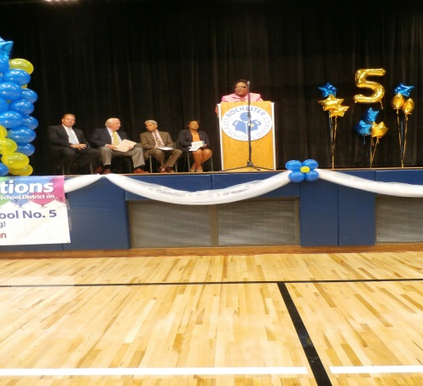

Greetings Parents and Guardians,

We have been working hard all summer and we are off to a great start for the 2014-15 school year! We have a newly renovated building, IPads in all K-2 classrooms, new computer carts, and Smartboards in over 95% of the classrooms.

This year we are looking to offer a variety of parent workshops that will further foster the school/family relationships. Also, I will be leading our “Eating Breakfast with the Principal” to hear your concerns and share with you how we are doing in reaching our goals in the school’s SCEP (school comprehension educational plan) once a month. I am also excited to have Sylvan Learning to offer additional academic services to our students for ten weeks each semester after school (Tuesdays and Thursdays). The first day is scheduled for October 7. Applications are now available.

Your child’s safety is very important to us at School #5. If you have not already turned in the “emergency contact” form, we need you to do so immediately. The names listed on the “emergency contact” form will allow parents and guardians permission to enter the building upon signing in the main office. Once the clerical staff identifies you, a visitor’s pass will be issued.

Again, we want to make sure that all students are safe. If the person’s name is not on the emergency contact list (which will be transferred into our student database), that person will not be allowed to enter the building and the principal will be notified. If you are not requesting permission to enter the building, you will not need to follow these procedures.

These procedures will be enforced during our regular school hours. Please be patient with us and know that your child’s safety comes first.

Our Vision Statement:

All students will become academically prepared and responsible members of the greater community.

Our Mission Statement:

Through rigorous individualized instruction, John Williams School No. 5 will provide students with the academic knowledge and social skills to become independent, reflective learners. Our Vision Statement:

All students will become academically prepared and responsible members of the greater community.

Our Mission Statement:

Through rigorous individualized instruction, John Williams School No. 5 will provide students with the academic knowledge and social skills to become independent, reflective learners.[Type a quote from the document or the summary of an interesting point. You can position the text box anywhere in the document. Use the Drawing Tools tab to change the formatting of the pull quote text box.]

JOHN WILLIAMS SCHOOL NO. 5—*We Are a Family*

Sylvan Program at School #5

Sylvan is pleased to offer support for student achievement at John Williams School No. 5. Sylvan Learning’s educational programs are based on well-grounded theories of teaching, learning and research based evidence regarding effective instructional practices. The Sylvan Learning Ace it! Programs specifically focus on increasing achievement of at-risk students who have difficulty reaching proficiency and benefit from enhanced interaction in order to obtain their academic and personal goals. The Sylvan curriculum and instructional models facilitate direct instruction and student engagement, use a low student-to-teacher ratio, explicit instruction with immediate feedback, scaffolding, and strategic questioning. Instructional methods incorporate research-based instruction with student motivation techniques and parent involvement in order to develop critical thinking and analytical reasoning skills as related to the Common Core Learning Standards.

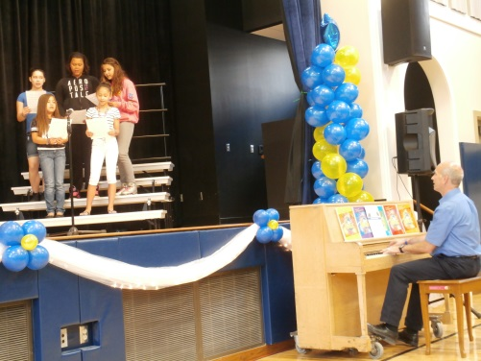

If you are a parent/guardian of a preschooler, you should already have a “preschooler” pass. However, if you forget to bring your pass, you will need to sign-in at the main office. Please make sure that the pass is visible at all times while in the building.

We thank you in advance for your patience and understanding. We are also thrilled to inform you that all classrooms have an extra cylinder safety lock which prevents intruders from entering the room. Safety is our top priority here at School #5!

Joanne Wideman, Principal

Reminder of dismissal locations:

Main entrance for preschoolers Plymouth Avenue

Walkers for kindergarteners at corner of Plymouth Avenue and Jay Street (Exit 2)

Walkers for grades 1-8 middle of school on Jay Street (Exit 3)

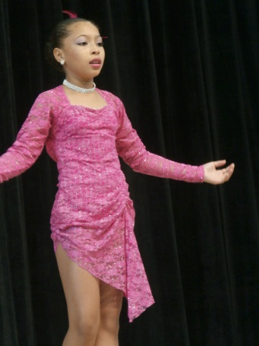

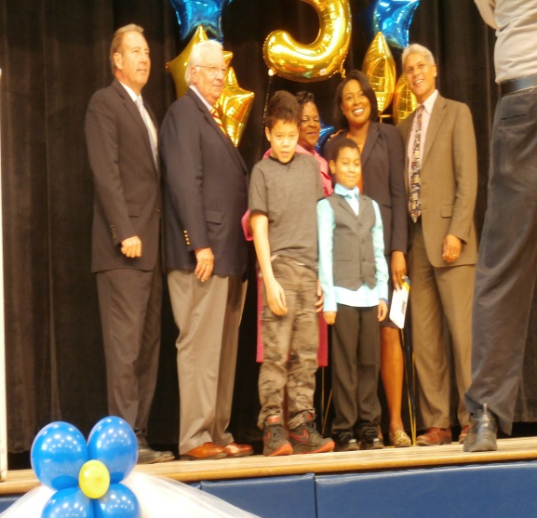

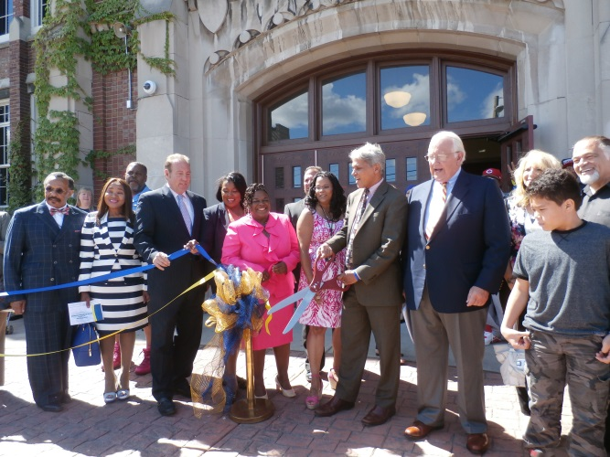

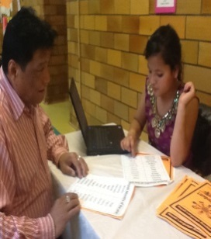

PTO

Meeting

#### Save the Date!

##### Open House/

##### Curriculum Night

##### Parent /Teacher

##### Conference

November 13th

5-7pm

September 25th

5-7:30pm

5:30-6:30pm

October 6th

**UNITY**

Our Vision Statement:

All students will become academically prepared and responsible members of the greater community.

Our Mission Statement:

Through rigorous individualized instruction, John Williams School No. 5 will provide students with the academic knowledge and social skills to become independent, reflective learners.

*I dreamt I stood in a studio,*

*And watched two sculptors there.*

*The clay they used was a young child’s mind,*

*And they fashioned it with care.*

*One was a teacher—the tools she used,*

*Were books, music, and art.*

*The other, a parent—working with a guiding hand,*

*And a gentle loving heart.*

*Day after day, the teacher toiled*

I know how much your children loved receiving the new books at the end of the year. Please continue to read with them throughout the school year.

Children who see their parents reading are more likely to read themselves so pick up a book with your child and share a love for reading!

*With a touch that was deft and sure.*

*While the parent labored by her side,*

*And polished and smoothed it o’er.*

*And when at last, their task was done,*

*They were proud of what they had wrought.*

*For the things they had molded into the child,*

*Could neither be sold nor bought.*



*And each agreed they would have failed*

*If each had worked alone,*

*For behind the teacher stood the school,*

*And behind the parent, the home.*

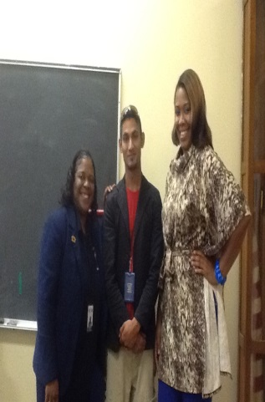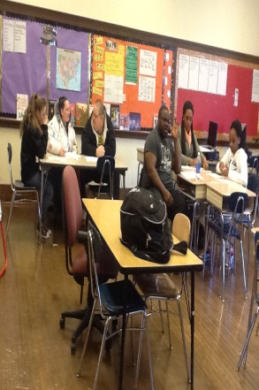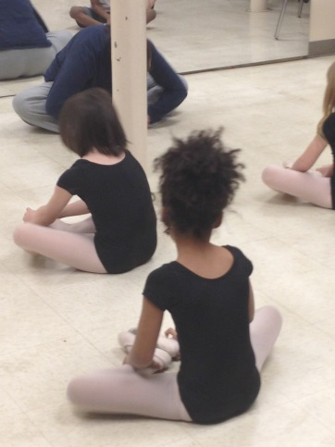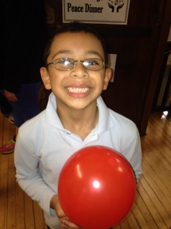*- Author Unknown*

